NAGAR YUWAK SHIKSHAN SANSTHA’S
YESHWANTRAO CHAVAN COLLEGE OF ENGINEERING
(An Autonomous Institution affiliated to Rashtrasant Tukadoji Maharaj Nagpur University)
Hingna Road, Wanadongri, Nagpur – 441 110
NAAC A++

WEB TECHNOLOGY – MSPA 2 & 3

STUDENT NAME: Vinit Bagwe
ROLL NO.: 69
BRANCH / YEAR: COMPUTER TECHNOLGY 3RD SEM
GUIDED BY: HARSHA TEMBHEKAR

PROBLEM 1: Student Task Manager

1. PROBLEM STATEMENT
Students often manage assignments, practical work, tests, and deadlines using separate notes or memory. This can make it difficult to track pending work. The proposed Student Task Manager provides one simple interface to maintain tasks and identify which tasks are still pending.

2. CODE
Save the following code as index.html and open it in a modern web browser. Internet access is required for API-based features.
<!DOCTYPE html>
<html lang="en">
<head>
<meta charset="UTF-8">
<meta name="viewport" content="width=device-width, initial-scale=1.0">
<title>Student Task Manager</title>
<style>
body { font-family: Arial, sans-serif; max-width: 650px; margin: 30px auto; padding: 16px; }
li { margin: 10px 0; }
.done { text-decoration: line-through; color: gray; }
</style>
</head>
<body>
<h1>Student Task Manager</h1>
<input id="taskInput" placeholder="Enter a task">
<button id="addBtn">Add Task</button>
<p id="summary">Pending: 0 | Completed: 0</p>
<ul id="taskList"></ul>
<button id="loadBtn">Load Sample Tasks</button>
<script>
let tasks = [];
const input = document.getElementById('taskInput');
const list = document.getElementById('taskList');
const summary = document.getElementById('summary');
function renderTasks() {
list.innerHTML = '';
tasks.map(task => {
const li = document.createElement('li');
const label = document.createElement('span');
label.textContent = task.title;
if (task.completed) label.className = 'done';
const complete = document.createElement('button');
complete.textContent = task.completed ? 'Undo' : 'Complete';
complete.onclick = () => {
tasks = tasks.map(t => t.id === task.id ? {...t, completed: !t.completed} : t);
renderTasks();
};
const remove = document.createElement('button');
remove.textContent = 'Delete';
remove.onclick = () => {
tasks = tasks.filter(t => t.id !== task.id);
renderTasks();
};
li.append(label, ' ', complete, ' ', remove);
list.appendChild(li);
});
const completed = tasks.reduce((n, t) => n + (t.completed ? 1 : 0), 0);
summary.textContent = `Pending: ${tasks.length - completed} | Completed: ${completed}`;
}
document.getElementById('addBtn').onclick = () => {
const title = input.value.trim();
if (!title) return alert('Please enter a task.');
tasks.push({id: Date.now(), title, completed: false});
input.value = '';
renderTasks();
};
document.getElementById('loadBtn').onclick = async () => {
try {
const response = await fetch('https://jsonplaceholder.typicode.com/todos?_limit=5');
if (!response.ok) throw new Error('Request failed');
const data = await response.json();
tasks = data.map(t => ({id: t.id, title: t.title, completed: t.completed}));
renderTasks();
} catch (error) {
alert('Could not load sample tasks. Check your internet connection.');
}
};
</script>
</body>
</html>

3. OUTPUT
The page displays a task input and Add Task button. Added tasks appear in a list. Complete/Undo updates the status, Delete removes a task, and the summary shows pending and completed counts. Load Sample Tasks retrieves example tasks from the API when internet access is available.

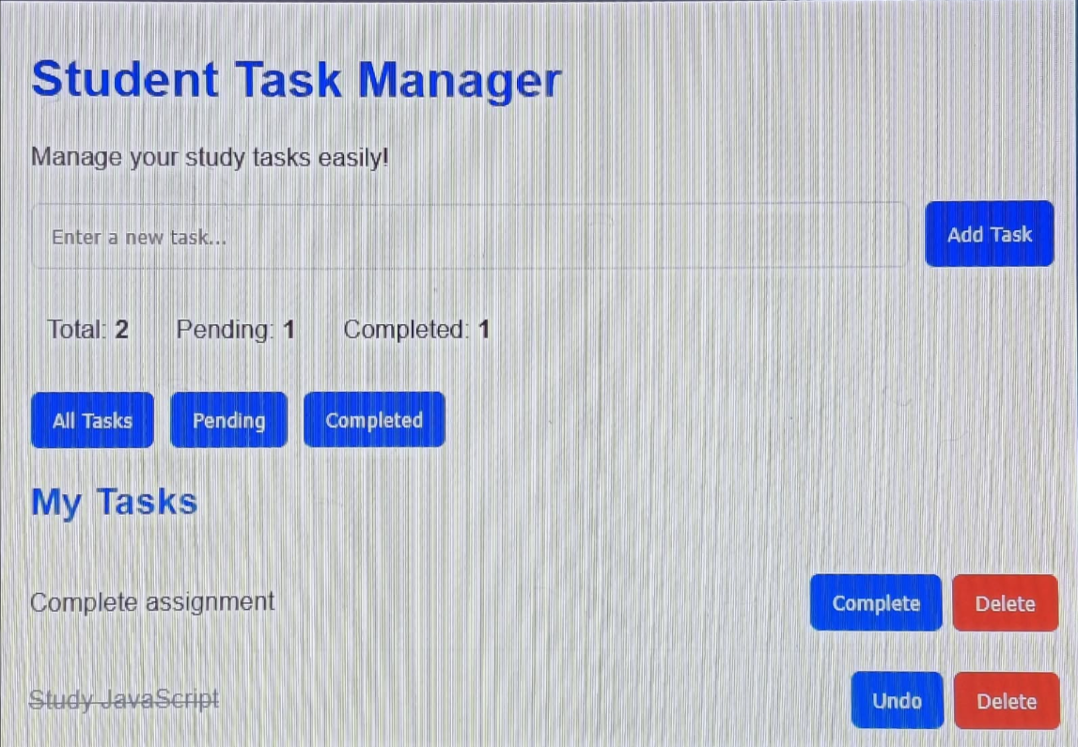
NAGAR YUWAK SHIKSHAN SANSTHA’S
YESHWANTRAO CHAVAN COLLEGE OF ENGINEERING
(An Autonomous Institution affiliated to Rashtrasant Tukadoji Maharaj Nagpur University)
Hingna Road, Wanadongri, Nagpur – 441 110
NAAC A++

WEB TECHNOLOGY – MSPA 2 & 3

STUDENT NAME: Vinit Bagwe
ROLL NO.: 69
BRANCH / YEAR: COMPUTER TECHNOLGY 3RD SEM
GUIDED BY: HARSHA TEMBHEKAR

PROBLEM 3: Movie Search Application

1. PROBLEM STATEMENT
Finding information about a movie or show can require visiting multiple pages. This project provides a single search interface that retrieves matching titles and displays useful details. The TVMaze API is used because it provides public search data without requiring an API key; its search endpoint primarily returns TV-show information.

2. CODE
Save the following code as index.html and open it in a modern web browser. Internet access is required for API-based features.
<!DOCTYPE html>
<html lang="en">
<head>
<meta charset="UTF-8">
<meta name="viewport" content="width=device-width, initial-scale=1.0">
<title>Movie / TV Show Search</title>
<style>
body { font-family: Arial, sans-serif; max-width: 800px; margin: 25px auto; padding: 16px; }
article { border-bottom: 1px solid #ddd; padding: 12px 0; }
img { max-width: 90px; float: left; margin: 0 12px 8px 0; }
.clear { clear: both; }
</style>
</head>
<body>
<h1>Movie / TV Show Search</h1>
<input id="query" placeholder="Enter a title">
<button id="searchBtn">Search</button>
<p id="message"></p>
<section id="results"></section>
<h2>Selected Shows (<span id="count">0</span>)</h2>
<section id="selected"></section>
<script>
let selectedShows = [];
const results = document.getElementById('results');
const message = document.getElementById('message');
function cleanSummary(summary) {
const temp = document.createElement('div');
temp.innerHTML = summary || '';
return temp.textContent || '';
}
function renderSelected() {
const box = document.getElementById('selected');
box.innerHTML = '';
selectedShows.map(show => {
const row = document.createElement('p');
row.textContent = show.name + ' ';
const remove = document.createElement('button');
remove.textContent = 'Remove';
remove.onclick = () => {
selectedShows = selectedShows.filter(s => s.id !== show.id);
renderSelected();
};
row.appendChild(remove);
box.appendChild(row);
});
document.getElementById('count').textContent =
selectedShows.reduce(count => count + 1, 0);
}
document.getElementById('searchBtn').onclick = async () => {
const query = document.getElementById('query').value.trim();
if (!query) {
message.textContent = 'Please enter a title.';
return;
}
message.textContent = 'Searching...';
results.innerHTML = '';
try {
const response = await fetch('https://api.tvmaze.com/search/shows?q=' + encodeURIComponent(query));
if (!response.ok) throw new Error('Request failed');
const data = await response.json();
message.textContent = data.length ? 'Search results:' : 'No matching shows found.';
data.map(entry => {
const show = entry.show;
const article = document.createElement('article');
const title = document.createElement('h3');
title.textContent = show.name;
article.appendChild(title);
const year = show.premiered ? show.premiered.slice(0, 4) : 'Not available';
const details = document.createElement('p');
details.textContent = `Premiere year: ${year}. ${cleanSummary(show.summary)}`;
article.appendChild(details);
if (show.image && show.image.medium) {
const img = document.createElement('img');
img.src = show.image.medium;
img.alt = show.name + ' poster';
article.prepend(img);
}
const add = document.createElement('button');
add.textContent = 'Save';
add.onclick = () => {
if (!selectedShows.some(s => s.id === show.id)) {
selectedShows.push({id: show.id, name: show.name});
renderSelected();
}
};
article.appendChild(add);
const clear = document.createElement('div');
clear.className = 'clear';
article.appendChild(clear);
results.appendChild(article);
});
} catch (error) {
message.textContent = 'Search failed. Check your internet connection and try again.';
}
};
</script>
</body>
</html>

3. OUTPUT
Enter a title and click Search. Matching TVMaze results appear with titles, available premiere years, summaries, and posters when provided by the API. Save adds a show to the selected list, Remove deletes it, and the selected count updates automatically.
